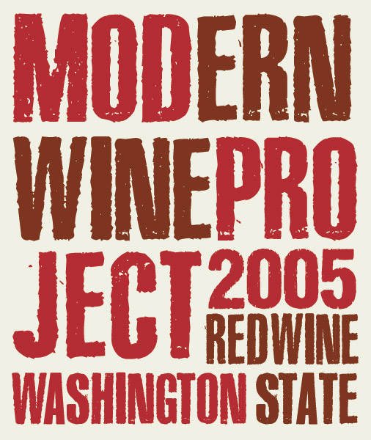

**2005 Modern Wine Project Red Wine**

**47% Merlot 27% Cab Franc 13% Cab Sauv 7% Malbec 6% Petit Verdot**

From the warm 2005 vintage in Washington State comes the “newest” release from the Modern Wine Project, a side label of the cult winery, Sleight of Hand Cellars, in Walla Walla, WA. Like the previous vintage, these wines have been impeccably cellared for years, waiting for the wines to awake from their slumber. This wine is just entering its “drink now” stage, and shows amazing richness, purity, and vibrancy for a wine that is 8 years old. You would expect to pay twice the price for what is in the bottle. This red blend was aged in mostly new French oak for 30 months, and as mentioned previously, has been in bottle for the last 5 years, undisturbed and waiting for this release date! The Washington State Bordeaux-style blend has wonderfully complex flavors and aromas of red and black fruits, dried figs, roasted coffee beans, herbs, and finishes with plush, approachable tannins that carry the mineral finish for minutes. Meant to share and impress, we hope you buy several for your next dinner party!